Zoe Cesar

cs 4720 Spring 2018  Professor Sharon Perry

The Cracked Girl

My website is a portfolio. It has a home page, an about page, a work page, and a blog page. My site is built using Angular as the framework and uses Google Firebase to store photos and blog posts. I chose this project because I wanted to learn more about web development, but I also wanted to build a personal website that I can use. Websites are very important to have because they showcase your work. As a photographer, videographer and programmer, websites are an essential part of branding and marketing. I took on the challenge of using Angular and Firebase because they are tools that are in high demand in the web industry, so I wanted to be able to showcase my skills with these tools.

Final Site UI:

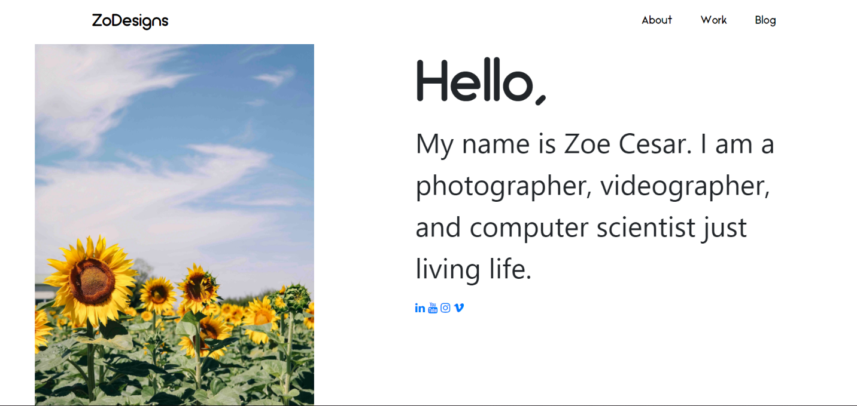

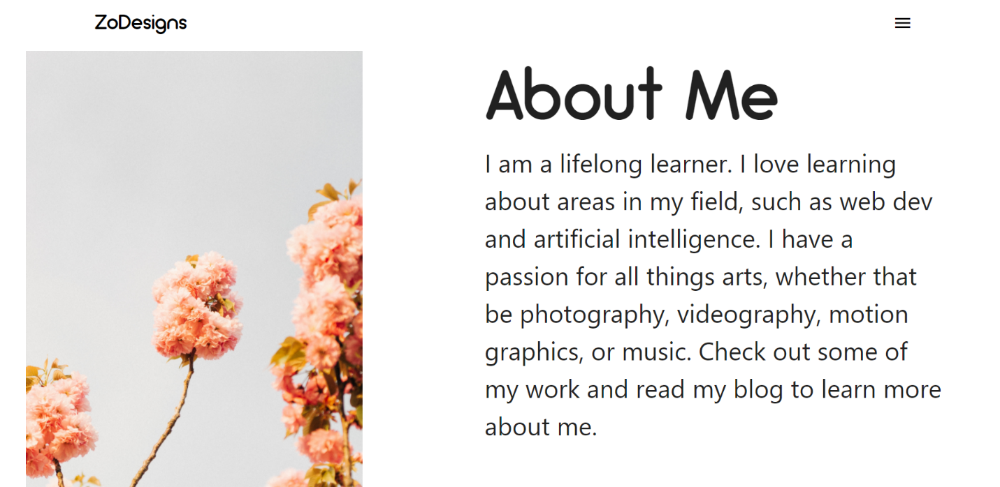

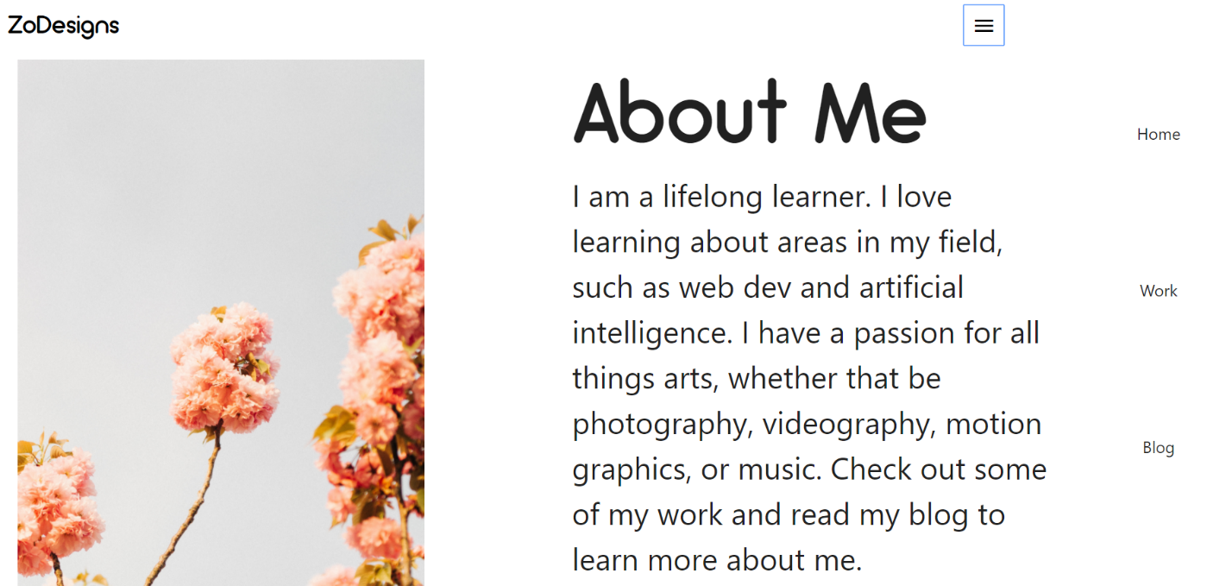

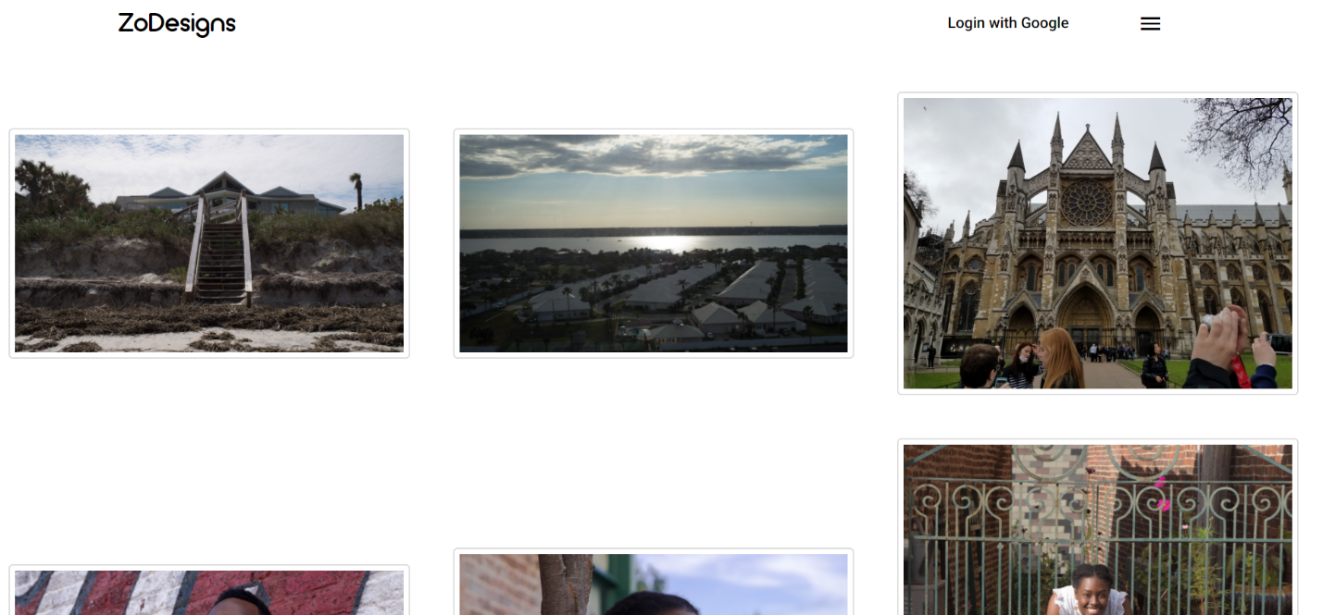

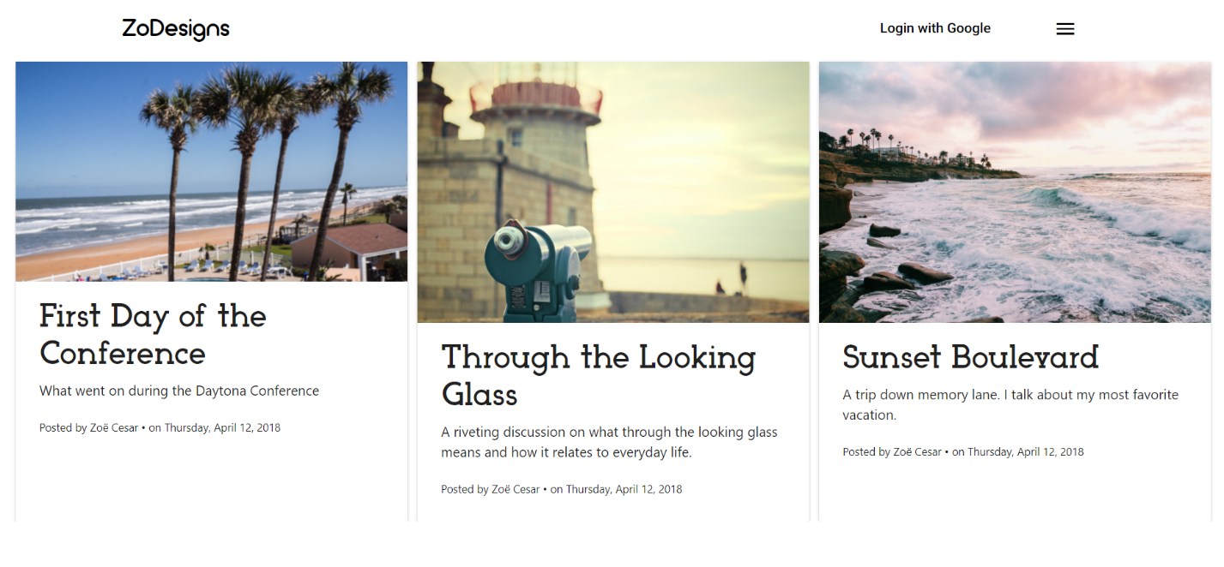

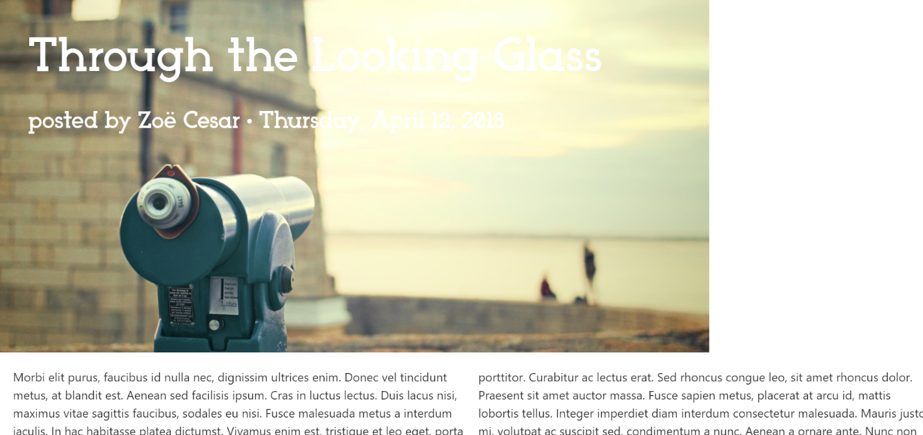

My site is complete with some minor changes from my initial proposal. My initial UI design was flawed, so I made changes to it. There is no contact form anymore, as I saw that as an irrelevant addition to my site. Instead, I linked my various social media where I could be contacted if needed. I also forgot to include a blog list page, so that users could see all the blog posts and choose the one they want to read, so that was added.

Some challenges I encountered was the use of Firebase and Angular. As I have never worked with either software before, I had to learn how to work with them. I also had trouble with Angular’s routing system. I was having problems getting my routes to display properly, but I was able to fix that issue by changing how the code was structured. Another challenge I faced using Angular was utilizing Angular Material. Angular Material is an open source library that provides components to use with an Angular project, such as forms, cards, toolbars, dialogs, etc. It was a learning curve to figure out how to use these materials optimally, as the documentation for certain components were very vague. It took a lot of trial and error to get the material components to work the way I wanted to for the site. Another UI challenge I encountered was with the blog posts. Since every blog post is automatically formatted the same way, I encountered many limitations with how I could display the posts and how long my titles could be due to them being too long for the image. With Firebase, I had to learn how to import it into Angular and then upload to it and retrieve the uploaded content. This involved creating service files in Angular that stored methods to upload and retrieve posts posted in Firebase.

Overall, I have learned a lot from this project. I learned how to build a site with Angular and how to use Firebase. I also learned how to use Angular Material to style my site. From a UI perspective, I learned how to use SASS, as that was my style framework. Another thing I took away from the UI/UX design was minimalistic design and how not all elements are needed, like a contact form, when users can contact you through other means and view more of your work through those links as well. When I revisit this project, I will create an admin and user version of the site. That way, only the admin can add posts, photos and edit posts. I would also find a way to retrieve photos from Firebase Storage instead of creating a collection of photos. That way, I can upload a multitude of photos directly, instead of uploading them to the website, which then uploads the photos to Firebase.